* It involves searching the string from right to left in the pattern.
* It is very good for random text strings.

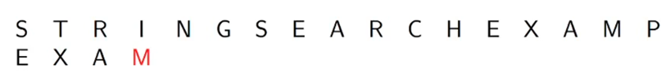

* Here unlike the brute force string matching which is from left to right, here comparison would mostly be done from right to left. So as we can see in the above example, as the pattern has no occurrence of the **character** **I** it would be slide 4 positions along.
* This is based only on knowing the pattern.
* The pattern gets shifted by entire length.

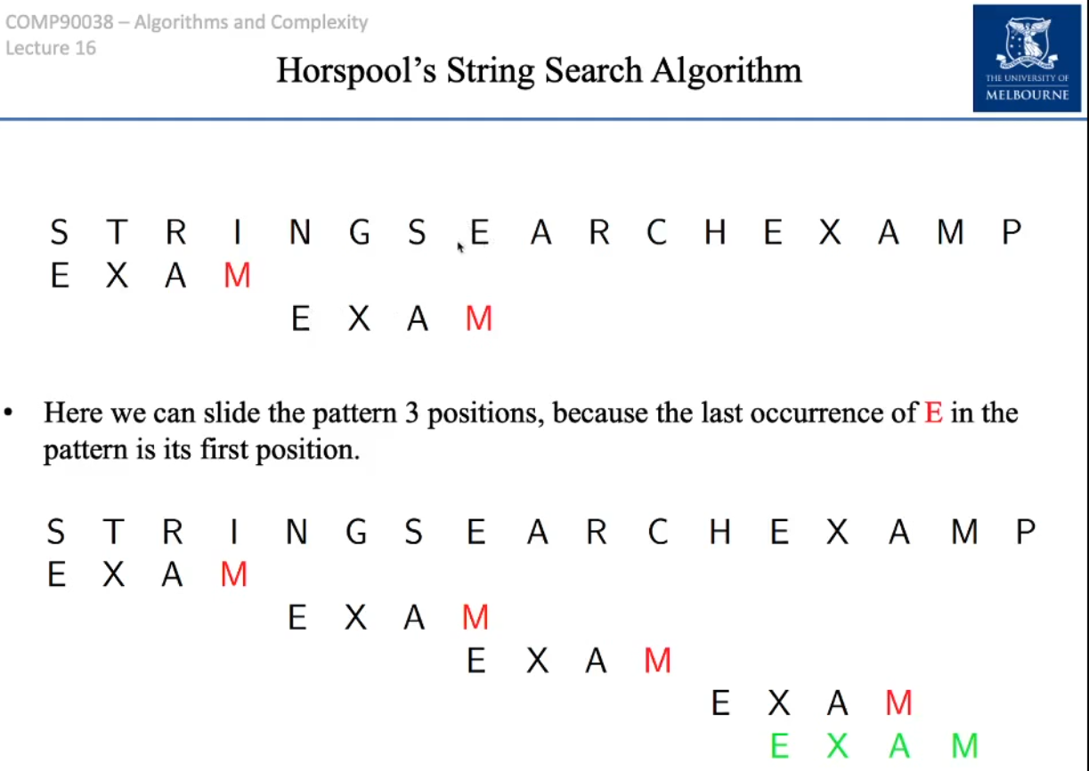

What happens when we have longer partial matches?

In that case, we would need to develop a shift table.

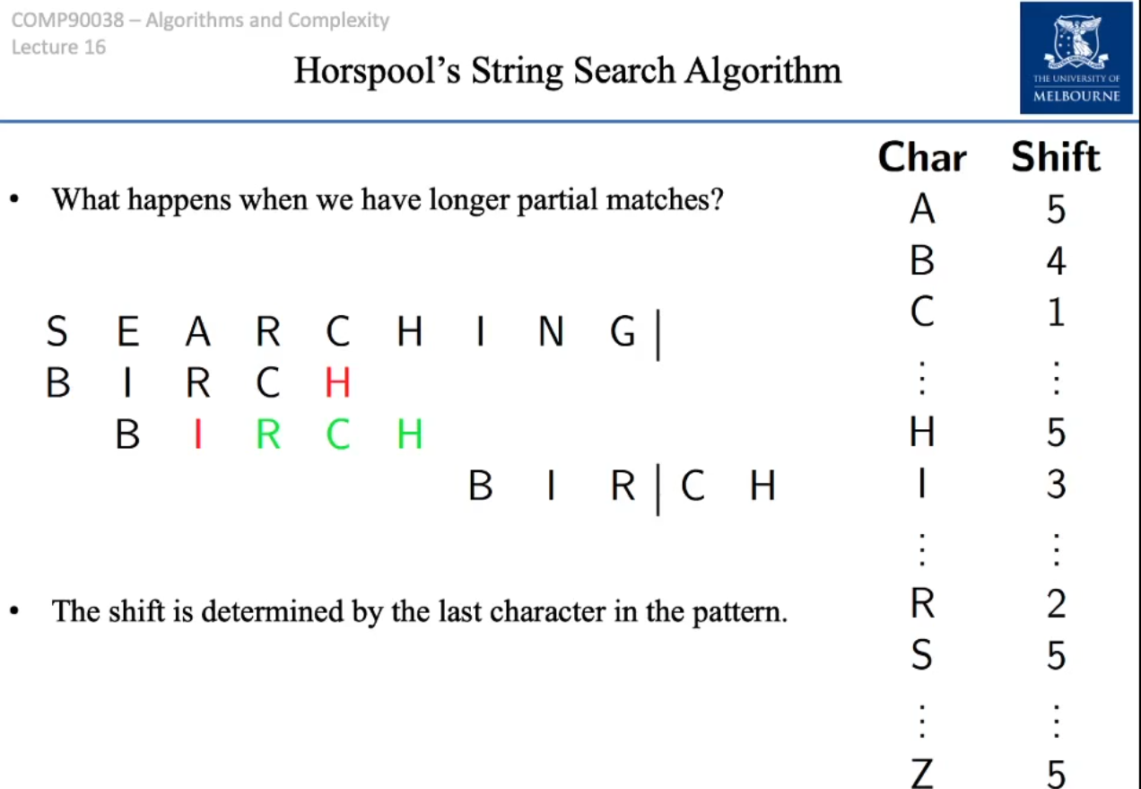

When we have longer partial matches we would need to develop a shift table.



B is 4 positions apart from the current match; therefore we would assign the shift value of B to be equal to 4.



C is 1 position away from the far right hand side of the pattern. So we would assign the shift value of C to be 1.

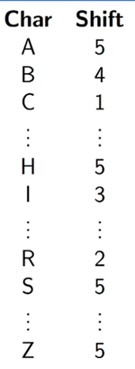



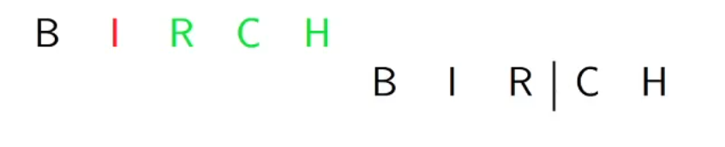

The next value of H is again 5 positions away from the previous value of H in the first string.